Advance SQL

Stored Procedure for employee

-- Select all employee

CREATE PROCEDURE SelectAllEmployee

AS

SELECT * FROM poojan_employee;

EXEC SelectAllEmployee;

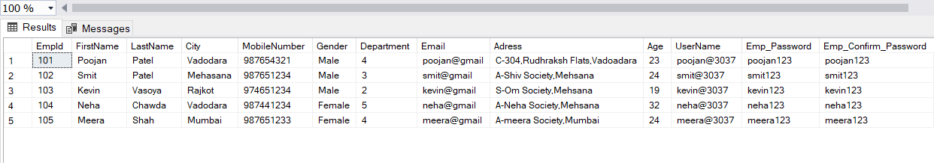

--Insert new record

CREATE PROCEDURE newEmployeeInsert_Poojan

@empid INT,

@fname VARCHAR(15),

@lname VARCHAR(15),

@city VARCHAR(20),

@number INT ,

@gender VARCHAR(7) ,

@department INT ,

@email VARCHAR(15) ,

@adress VARCHAR(100) ,

@age INT,

@userName VARCHAR(15) ,

@emp_Password VARCHAR(10) ,

@emp_Confirm_Password VARCHAR(10)

As

BEGIN

INSERT INTO poojan_employee(EmpId, FirstName, LastName, City, MobileNumber, Gender, Department, Email, Adress, Age, UserName, Emp_Password, Emp_Confirm_Password)

VALUES(@empid,@fname,@lname,@city,@number,@gender,@department,@email,@adress,@age,@userName,@emp_Password,@emp_Confirm_Password)

END

GO

EXEC newEmployeeInsert_Poojan 105,'Meera','shah','Surat',1,'female',5,'meera@3037','C-101,Shiv Flats',21,'meera3037','1234','1234';

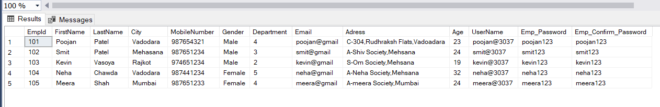

--update employee

CREATE PROCEDURE updateEmployee_Poojan

@number INT,

@id INT

AS

BEGIN

UPDATE poojan_employee SET MobileNumber=@number WHERE EmpId=@id

END

go

EXEC updateEmployee_Poojan @id=105,@number=98765432

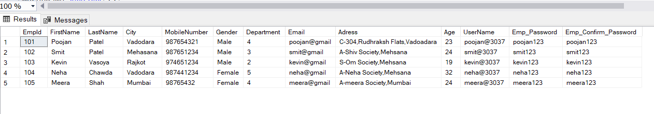

--delete employee

CREATE PROCEDURE deleteEmployee_Poojan

@id INT

AS

BEGIN

DELETE FROM poojan_employee WHERE EmpID=@id;

END

GO

EXEC deleteEmployee_Poojan @id=105;

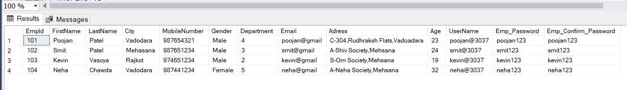

Stored Procedure for department

---- Select all data of Department

CREATE PROCEDURE selectAllDeaprtmentPoojan

AS

SELECT * FROM poojan_Department;

EXEC selectAllDeaprtmentPoojan;

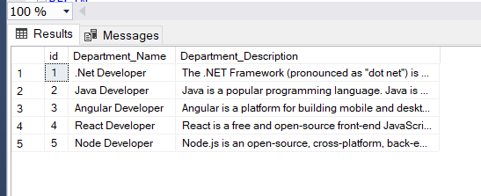

--Insert new record

CREATE PROCEDURE newDepartmentPoojan

@id INT,

@dname VARCHAR(20) ,

@dDescription VARCHAR(200)

As

BEGIN

INSERT INTO poojan_Department VALUES (@id,@dname,@dDescription)

END

GO

EXEC newDepartmentPoojan 6,'Graphics Desienger','Design website'

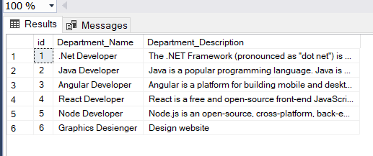

--update department

CREATE PROCEDURE updateDepartment_Poojan

@id INT,

@dname VARCHAR(20)

AS

BEGIN

UPDATE poojan_Department SET Department_Name=@dname WHERE id=@id

END

go

EXEC updateDepartment_Poojan @id=6,@dname='Graphic Developer'

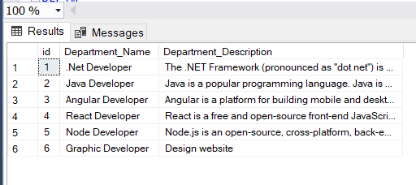

--delete department

CREATE PROCEDURE deleteDpartmentPoojan

@id INT

AS

BEGIN

DELETE FROM poojan_Department WHERE id=@id

END

GO

EXEC deleteDpartmentPoojan 6

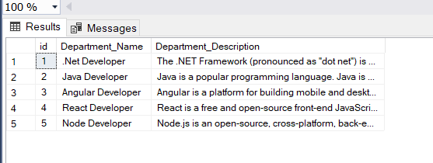

Stored Procedure for Exam

---- Select all data of Exam

CREATE PROCEDURE selectAllExamPoojan

AS

SELECT * FROM poojan_exam;

EXEC selectAllExamPoojan;

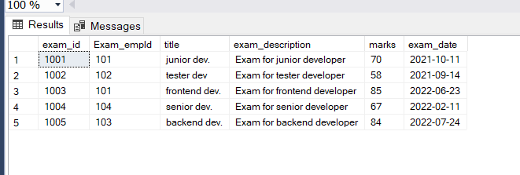

--Insert new record

CREATE PROCEDURE newExamPoojan

@id INT,

@exam_empId INT,

@title VARCHAR(15),

@exam_description VARCHAR(100),

@marks INT,

@exam_date DATE

As

BEGIN

INSERT INTO poojan_exam VALUES (@id,@exam_empId,@title,@exam_description,@marks,@exam_date)

END

GO

EXEC newExamPoojan 1006,102,'backend dev.','Exam for backend developer',45,'2022-07-24'

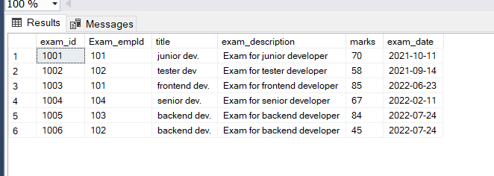

--update Exam

CREATE PROCEDURE updateExam_Poojan

@id INT,

@marks INT

AS

BEGIN

UPDATE poojan_exam SET marks=@marks WHERE exam_id=@id

END

go

EXEC updateExam_Poojan @id=1006,@marks=70

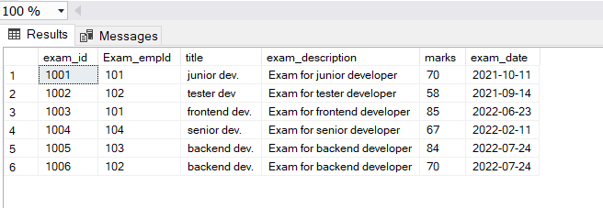

--delete Exam

CREATE PROCEDURE deleteExamPoojan

@id INT

AS

BEGIN

DELETE FROM poojan_exam WHERE exam_id=@id

END

GO

EXEC deleteExamPoojan 1006

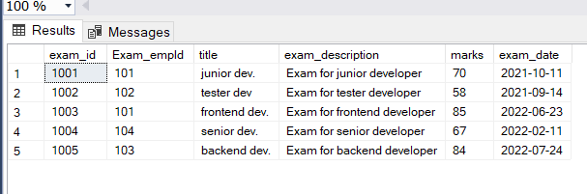

INNER JOINS

SELECT poojan_employee.FirstName,poojan_Department.Department_Name

FROM poojan_employee

INNER JOIN poojan_Department ON poojan_employee.Department = poojan_Department.id;

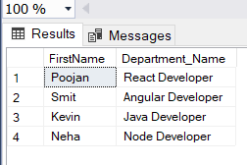

SELECT poojan_employee.FirstName,poojan_exam.title

FROM poojan_employee

INNER JOIN poojan_exam ON poojan_employee.EmpId = poojan_exam.Exam_empId;

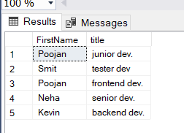

Left Join

SELECT poojan_employee.FirstName,poojan_Department.Department_Name

FROM poojan_employee

LEFT JOIN poojan_Department ON poojan_employee.Department = poojan_Department.id;

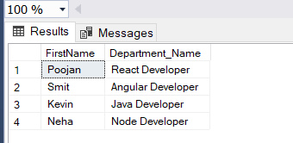

SELECT poojan_employee.FirstName,poojan_exam.title

FROM poojan_employee

Left JOIN poojan_exam ON poojan_employee.EmpId = poojan_exam.Exam_empId;

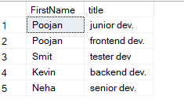

Right Join

SELECT poojan_employee.FirstName,poojan_Department.Department_Name

FROM poojan_employee

RIGHT JOIN poojan_Department ON poojan_employee.Department = poojan_Department.id;

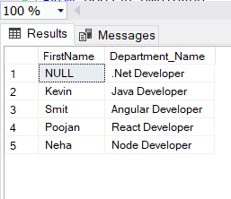

SELECT poojan_employee.FirstName,poojan_exam.title

FROM poojan_employee

RIGHT JOIN poojan_exam ON poojan_employee.EmpId = poojan_exam.Exam_empId;

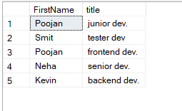

Full Join

SELECT poojan_employee.FirstName,poojan_Department.Department_Name

FROM poojan_employee

FULL JOIN poojan_Department ON poojan_employee.Department = poojan_Department.id;

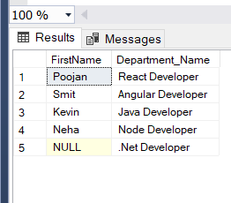

SELECT poojan_employee.FirstName,poojan_exam.title

FROM poojan_employee

FULL JOIN poojan_exam ON poojan_employee.EmpId = poojan_exam.Exam_empId;

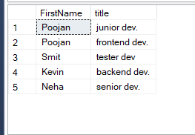

Trigger

-- trigger

CREATE TRIGGER poojan_Trigger

ON poojan_exam

FOR

INSERT,UPDATE,DELETE

AS

PRINT'changes applied on Exam Table'

ROLLBACK;

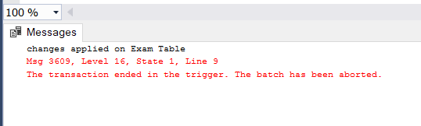

View

--view

CREATE VIEW [Employee Details] AS

SELECT FirstName,LastName,City

FROM poojan_employee

WHERE City = 'Vadodara';

SELECT * FROM [Employee Details];

